Experiment 7: Email Analysis Using Autopsy

1. Objective
To extract, examine, and analyze email artifacts from a forensic disk image using the Autopsy forensic tool.

2. INPUT
The input for this experiment is:
EmailEvidence.E01
The E01 image should contain email evidence such as:
normal_email.eml
suspicious_email.eml
attachment_email.eml
incomplete_email.eml
attachment.txt

3. PROGRAM / PROCEDURE

Before Creating Autopsy Case Create On Empty Folder Give Name Email Analysis

Step 1: Open Autopsy
Select:
Create New Case

Step 2: Create Case
Enter:
Case Name: Exp7
Base Directory: Email Analysis Saved Folder
Case Number: 7
Examiner:Student
Click Finish.

Step 3: Select Host
If Autopsy asks for the host, select:
Generate new host name based on data source name
Click Next.

Step 3: Add Evidence
Add Data Source
Select:
Disk Image or VM File
Click Next.

Step 4: Select E01 Image
Select:
C:\Forensic_Images\EmailEvidence.E01
Click Next.

Step 6: Processing
If your Autopsy version displays ingest/processing options, enable useful modules such as:
File Type Identification
Keyword Search
If the option does not appear, continue with the default processing.
Click next and finish.

Step 7: Examine Email Messages
In the left panel, open:
Data Artifacts
↓
E-Mail Messages
In your case, you may see:
E-Mail Messages (4)
Click it.

Step 8: Examine Email Headers
Select an email and examine:
From
To
Subject
Date/Time
Message-ID
Record the information.

Step 9: Examine Attachment
Open the email containing an attachment.
Check:
Attachment name
Attachment type
Attachment contents/metadata

Step 10: Examine Suspicious Email
Open the suspicious email.
Check for:
Suspicious sender
Urgent request
Password request
Account verification
Suspicious links
Suspicious attachment

Step 11: Examine Incomplete Email
Open the incomplete email.
Check which header fields are available and which are missing.

Step 12: Keyword Search
Use Keyword Search.
Search for:
urgent
password
verification
account
confidential
Record the matching results.

Step 14: Generate Report
Use:
Generate Report
Select an available format such as:
HTML
PDF
CSV

4. OUTPUT
After successful analysis, Autopsy should provide email artifacts such as:
E-Mail Messages (4)
Communication Accounts(8)
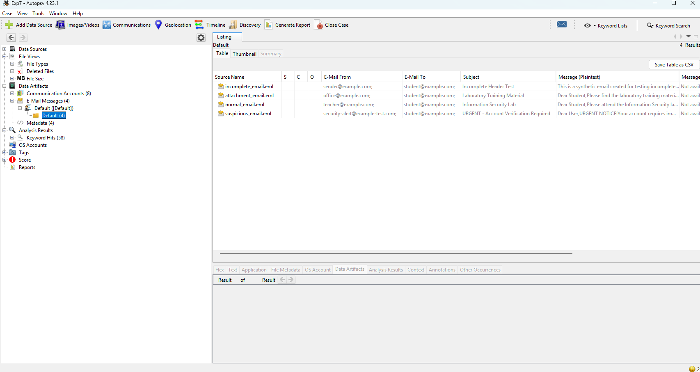
For each email,
Sender → Extracted
Receiver → Extracted
Subject → Extracted
Date/Time → Extracted
Message-ID → Extracted
Attachment → Identified

Normal Email:-
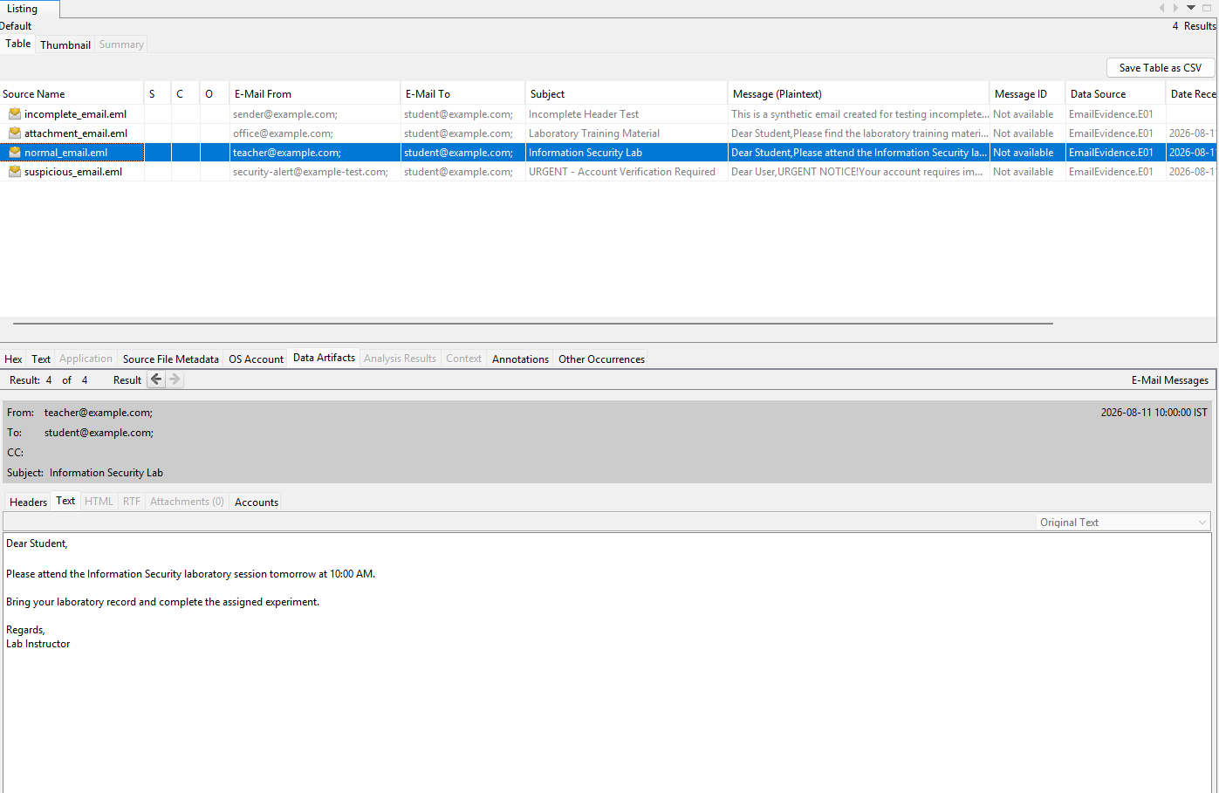

Attachment Email:-
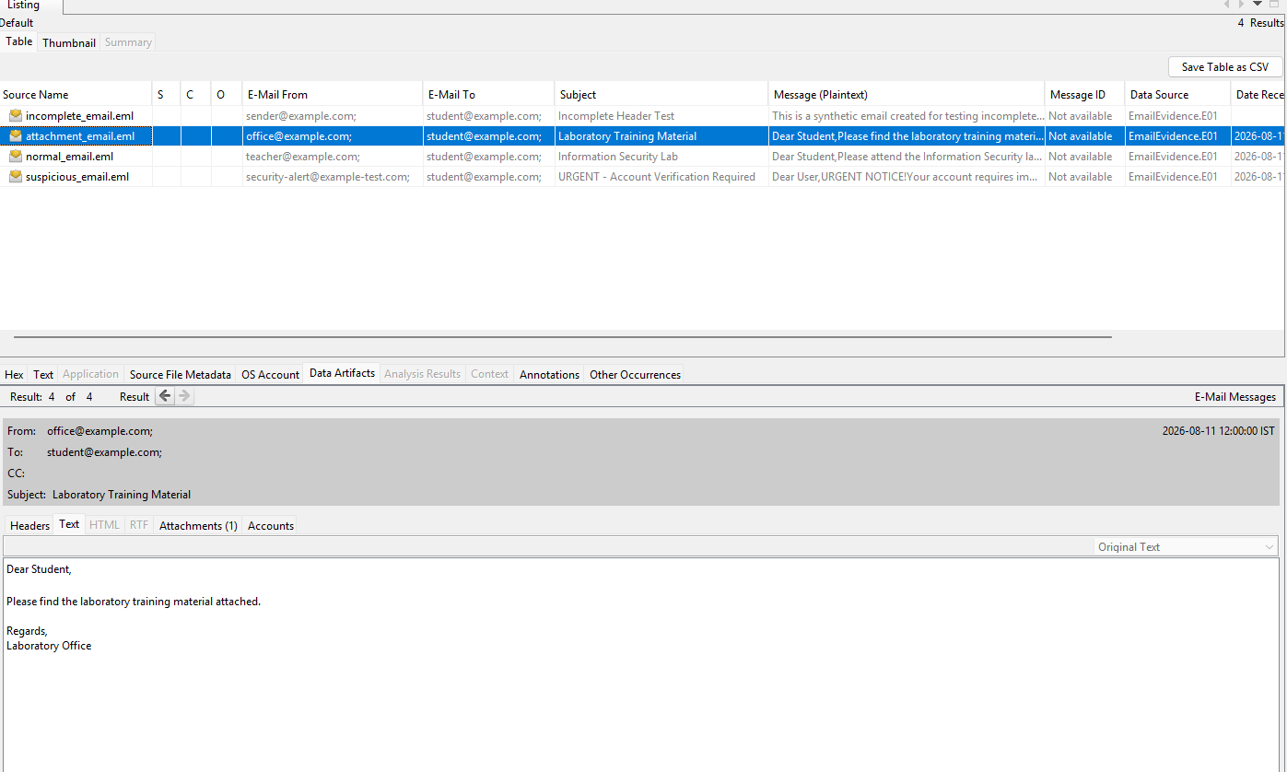
Suspicious emails:
Suspicious indicators → Identified

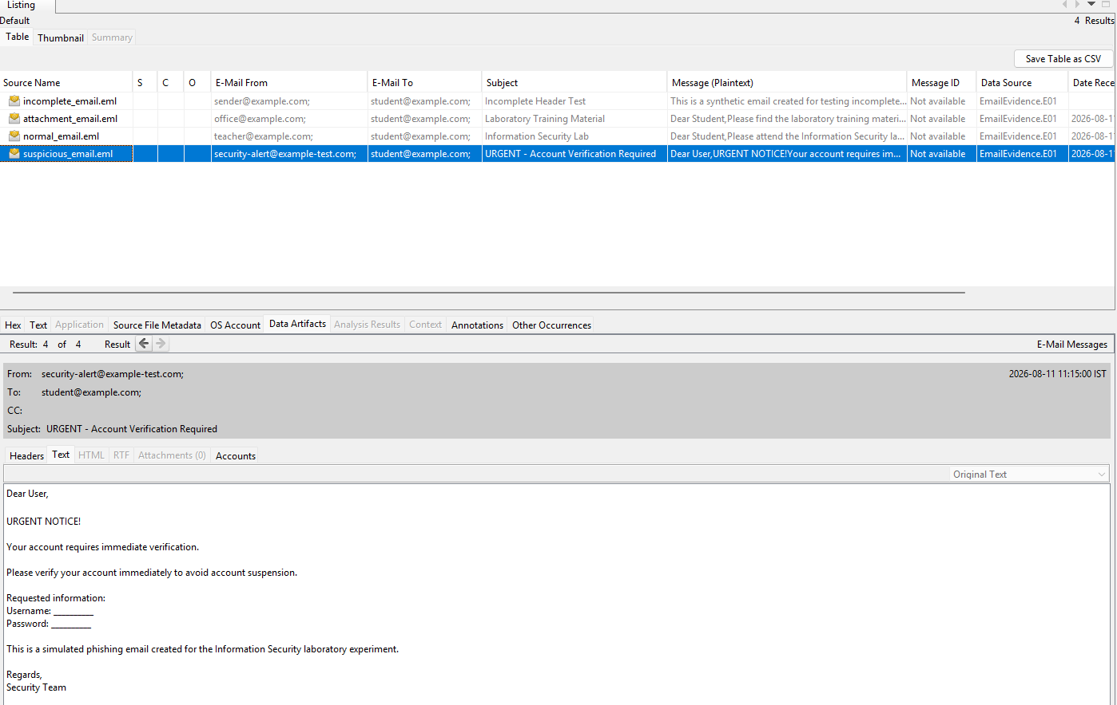
Incomplete emails:
Available metadata → Extracted
Missing fields → Reported

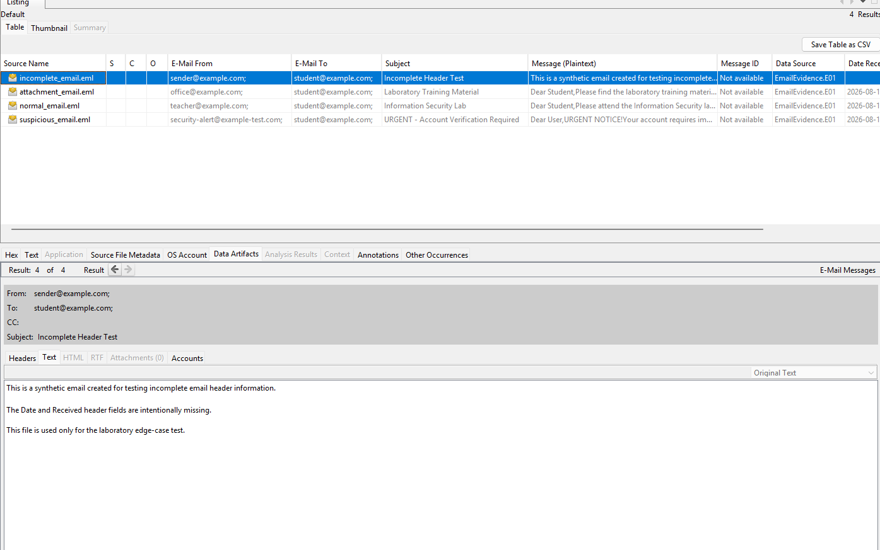

5. RESULT
The email artifacts from the forensic image were successfully extracted and analyzed using Autopsy. Sender, receiver, subject, timestamp, email headers, attachments, and suspicious indicators were examined. Keyword searching and analysis of incomplete email evidence were also successfully performed.

